**EXPERIMENT 4**  
Meet Kansara  
Reg. no.: 220929270  
Roll no.: 54

**Exercise Question 1:** Write a code using Energia in C/C++ - API interfacing to perform AND, OR, XOR and XNOR gate logic using onboard Pushbuttons and LED’s.

**AND**  
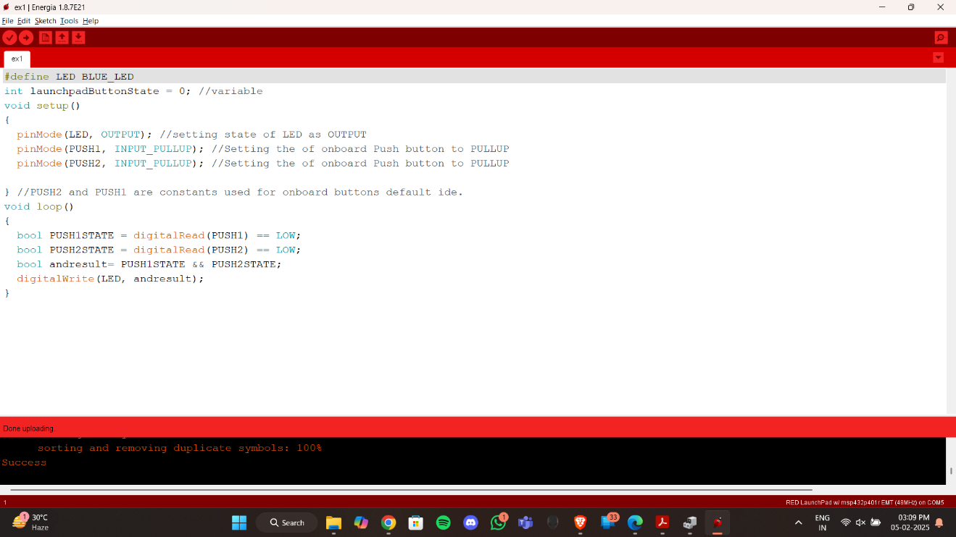

**OR**

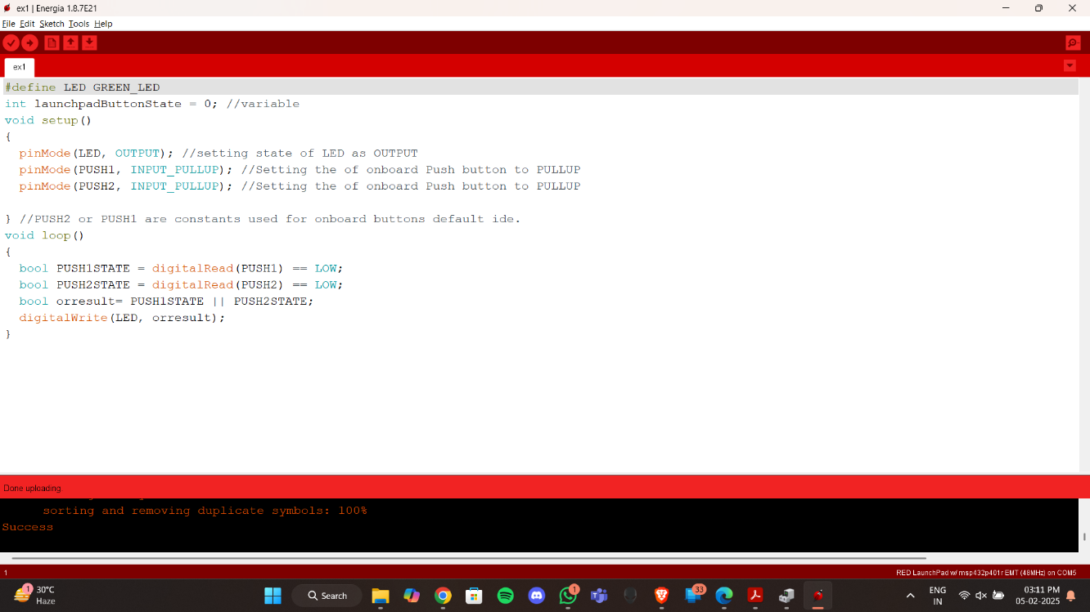

**XOR**

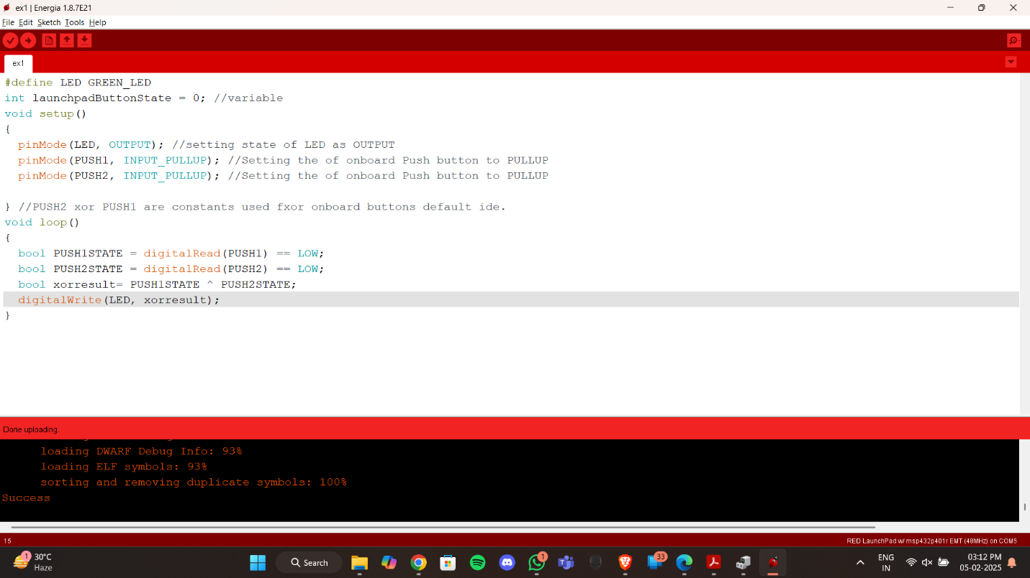

**XNOR**

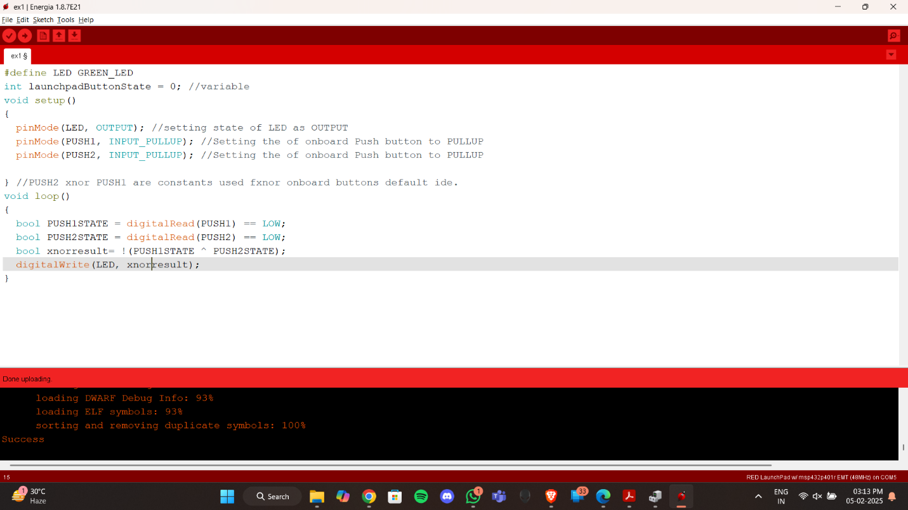

**Exercise Question 2:** Write a code using Energia in C/C++ - API interfacing to implement a Half adder using onboard Pushbuttons and LED’s.

**Exercise Question 3:** Construct a Truth Table for the logical functions at points C, D and Q in the following circuit and identify a single logic gate that can be used to replace the whole circuit.

The above circuit can be replaced by an OR gate to get the equivalent output

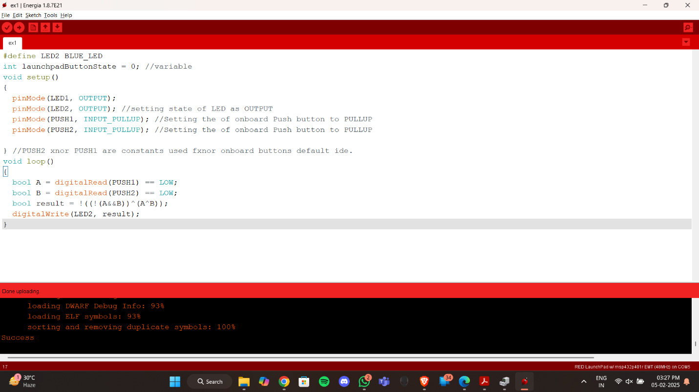

**Exercise Question 4:** Snerdley’s Automated Cafeteria orders a machine to dispense coffee and tea. Design the machine so that it has a button (input line) for each choice and so that a customer can have at most one of the two choices. Diagram the circuit to ensure that the “at most one” condition is met.

**Exercise Question 5:** The nation of Upper Slobovia has gained a missile defense capability governed by its Security Council. The Council consists of four members: the U.S. (Upper Slobovian) President and three Counselors (the Chiefs of Staff of the Army and Air Force plus the President’s Uncle Homer). The missile system is to be activated by a device obeying these rules: each member of the Security Council has a button to push; the missiles fire only if the President and at least one Counselor push their buttons. Design the rocket firing circuitry.

